* **Activity 7:**

Using the ANY Operator in Multiple-Row Subqueries

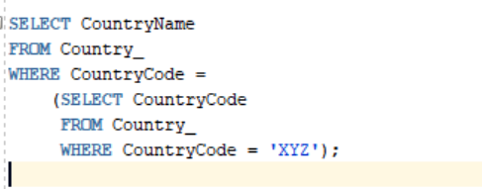

OUTPUT:

